**Jdbc driver**

Jdbc API contains a set of classes and Interfaces where classes definition is provided by Sun Micro System and Interfaces Implementation are not provided. For interface Implementation classes will be provided by vendors, these set of classes are called **Jdbc Driver Software**.

A Driver software contains set of classes among these classes one class is driver class.

Driver class is a mediator class between a java application and a database.

Java Application use Jdbc API and this API connect to driver class, then driver class connect to database.

**Types of jdbc driver**

JDBC Driver is a software component that enables java application to communicate with the database.There are 4 types of JDBC drivers, they are:

* Jdbc-Odbc Bridge Driver
* Native-API driver (partially java driver)
* Network Protocol driver (fully java driver)
* Thin driver (fully java driver)

### Short Description of Jdbc drivers

* Type 1 driver are database independent and platform dependent.
* Type 2 driver are database dependent and platform dependent.
* Type 3 driver are database independent and platform independent.
* Type 4 driver are database dependent and platform independent.

|  |  |  |
| --- | --- | --- |
| **Driver** | **Database** | **Platform** |
| Type - 1 | Independent | Dependent. |
| Type - 2 | Dependent | Dependent. |
| Type - 3 | Independent | Independent. |
| Type - 4 | Dependent | Independent. |

## Jdbc odbc bridge driver

This driver connect a java program with a database using Odbc driver. It is install automatically along with jdk software. It is provided by Sun MicroSystem for testing purpose this driver can not be used in real time application. This driver convert Jdbc calls into Odbc calls(function) So this is called a **bridge driver**.

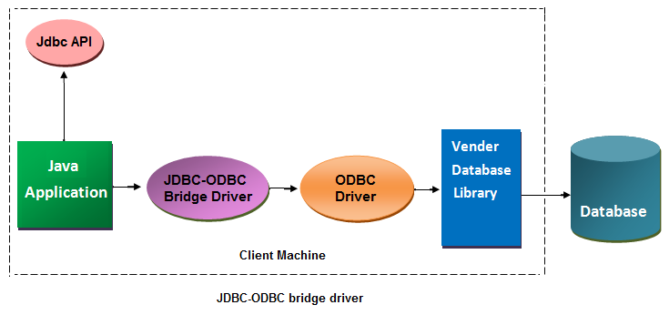

**Advantage of bridge driver**

* Easy to use
* It is a database independent driver
* Can be easily connected to any database.
* This driver software is built-in with JDK so no need to install separately.

**Disadvantage of bridge driver**

* It is a slow driver so not used in real time application
* Because of Odbc connectivity it is a platform dependent driver.
* It is not a portable driver.
* It is not suitable for applet to connect with database.